Name: | ___________________________________________________ |  |  | Date: ___________
 | Specialist Unit 1  Test 2, 2015  Topics – Vectors, Relative displacement and velocity |  |  | 49  = %
Total Time: | 60 minutes
Total Reading: | 5 minutes
Total Working: | 55 minutes
Weighting: | 5% of the year.
This test comprises of TWO sections. The first section is calculator free where no calculators of any kind are to be used. The second section is calculator assumed where a CAS calculator may be used. All questions must be answered in both sections. Answers should be rounded appropriately. All working should be shown in the space provided. Your working should be in sufficient detail to allow your answers to be checked readily and for marks to be awarded for reasoning. Incorrect answers given without supporting reasoning cannot be allocated any marks. For any question or part question worth more than two marks, valid working or justification is required to receive full marks.

No pens, pencils, highlights etc. may be used during reading time. This time is to be used to read through the assessment and check that you understand what is being asked of you. You may speak with the teacher/supervisor during this time (by putting up your hand and waiting patiently for them to approach you) but you may only ask clarification questions and not how to solve the problems. After reading time has ended, you may not ask any more questions.
SECTION 1: CALCULATOR FREE
Time: | 25 minutes | Marks for Section 1: | 23
Reading: | 2 minutes | Equipment Allowed: | Nil
Working: | 23minutes

1. | [5 marks: 1, 1, 1, 1, 1]
Complete this grid by drawing the resultant of the vector operations.
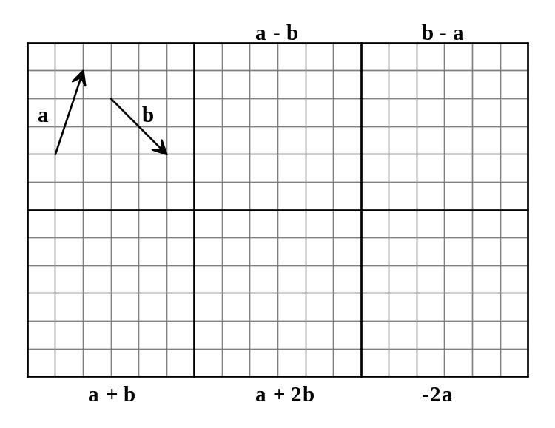

2. | [2 marks]
 | Given that 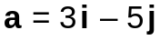 and , find k if │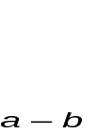│=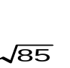
3. | [3 marks]
 | Seven people, including 3 friends, are seated in a row at random. In how many ways can the three friends be seated together?
4 | [4 marks]
Find n if:
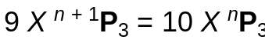

5. | [4 Marks]
 | Use the vectors (3, 2), (−2, 5) and (7, 3) to demonstrate that the scalar product is distributive over vector addition (i.e. a (b + c) = a b + a c).
6. | [5 Marks]
Given a = (–3, 5), b = (2, 7), c = (1, 9), d = (8, –2) and e = (–4, –2), find:
a e + e + e + e

b 5e

c 6d – 4b

d 3(2c – a)

e 8d – 12e

~ END OF TEST SECTION 1 ~

Name: | ___________________________________________________ |  |  | Date: ___________
SECTION 2: CALCULATOR ASSUMED
Time: | 30 minutes | Marks for Section 2: | 26
Reading: | 3 minutes | Equipment Allowed: | ½ page notes (A4 one side),  CAS calculator
Working: | 26 minutes

7. | [5 marks]
 | Find the magnitude and direction of the resultant of this pair of forces. Give your answer correct to two decimal places.
 | 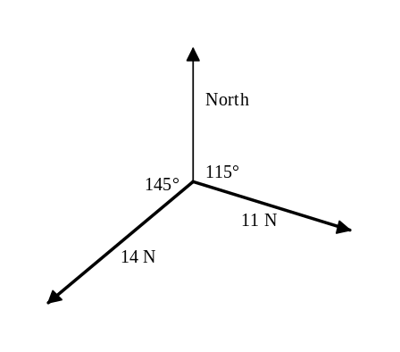

8. | [3 marks]
A large circular table at a restaurant has 9 people from an office seated at random around it.
What is the probability of Mary being seated between David and Peter?

9. | [7 marks: 2, 2, 3]
 | Given that a = -3i + 4j, b = 2i + j and c = 3i -2j find
a) | a unit vector in the same direction as b.
b) | a vector in the same direction as b but equal in magnitude to a.
c) | a vector in the same direction as the resultant of a, b and c but equal in magnitude to a.

10. | [5 marks]
 | An aircraft, heading due east in still air at an airspeed of 600 km/h⁻1. It encounters a wind blowing towards the north east at 50 km/h⁻1. Calculate the aircraft’s direction and ground speed.

11. | [6 marks: 3, 3]
 | A yacht is moving with velocity 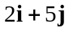 kmh⁻¹ relative to a stationary observer on the shore. A sailor on board the yacht measures the wind as blowing with velocity 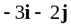 kmh⁻¹.
a) | Sketch a clearly labelled velocity vector diagram that shows the relationship between the velocity of the yacht relative to the shore, the velocity of the wind relative to the shore and the velocity of wind relative to the yacht.
b) | Find the velocity of the wind with respect to the stationary observer on the shore.

~ END OF TEST SECTION 2 ~

